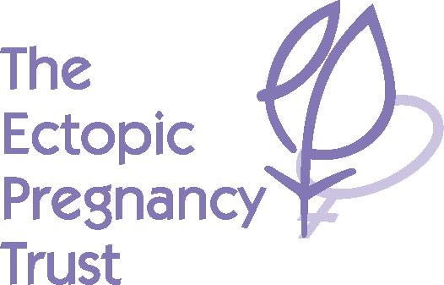

**Registered Charity Number: 1071811 (England & Wales) SC053187 (Scotland)**

[www.ectopic.org.uk](http://www.ectopic.org.uk)

[ept@ectopic.org.uk](mailto:ept@ectopic.org.uk)

##### **Letter of Authorisation regarding NAME, EPT80in1 Challenge**

The Ectopic Pregnancy Trust relies on the support of our generous fundraisers. While we are a UK-based charity giving support based on UK guidance, standards, and practice, we have international reach and audience and strive to provide a world-class service.

Our professional team manages our dedicated helpline and website including forums, which are open to both the public and professionals who need our assistance. We provide crucial support and information to thousands of women and their families as well as medical professionals who call our helpline and visit our website. We work with leading specialists in the field to bring the latest information and research to the widest audience, allowing women to have access to knowledge to make the best choice possible for them. We host conferences to teach medical professionals about better treatment and disseminate literature free of charge to hospitals across the UK.

To fund these services, the Trust requires £100,000 annually. We receive no government funding and do not charge for the provision of any of our services.

**NAME** has kindly chosen to raise funds for us by embarking on the **EPT80in1 Challenge** and has our permission to seek sponsorship for the challenge from those willing to support **her/him**. **NAME** will provide you with photographic identification (such as passport or driving licence), if required.

If you would like to contact The Ectopic Pregnancy Trust, please email us at [ept@ectopic.org.uk](mailto:ept@ectopic.org.uk) with any questions. Alternatively, we would be delighted to arrange a call to discuss any queries you may have.

Thank you for supporting **NAME** and, in so doing, supporting us here at the Trust.

Kind regards

The Ectopic Pregnancy Trust