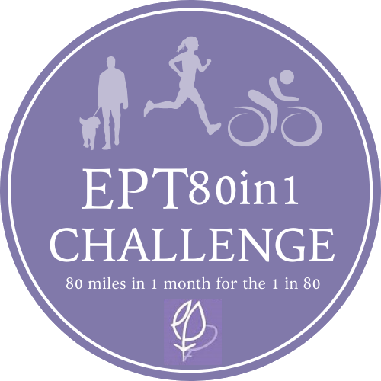

**The EPT80in1 Challenge - 80 miles in one month for the 1 in 80**

**1 in 80 pregnancies are ectopic. To highlight this common and life-threatening condition, tackle 80 miles in one month with the #EPT80in1 Challenge**

The challenge is either to run, walk, cycle or a mixture of all covering a distance of 80 miles over a month. You can track your activities manually using the sheet on our website or import from an exercising app such as MapMyRun, Strava, Garmin, Fitbit etc. Then gain support and increase awareness by telling everyone what you are doing and why and let them know where to find your online fundraising site.

**Take the 80in1 challenge!**

*“Since starting the challenge, it's been really encouraging to hear from friends and colleagues that they are so glad to see awareness being raised about ectopic pregnancy, and also for them to say that they had never really heard of it until now and that they are learning about it because of the challenge. One highlight was on one of the first runs Carmen and I did and a couple that we ran past smiled and shouted 'good cause!'. Thank you so much for organising, the whole experience has been so supportive”* ***Vicky talking about the challenge in 2020 whilst supporting her sister Carmen***

Ectopic pregnancy is a common, life-threatening condition that is a leading cause of death in early pregnancy. It affects 1 in 80 pregnancies in the UK and women have to face the physical trauma of major invasive treatment, their own mortality, the impact on their future fertility, and the heartbreak of losing their baby all in a short space of time. The impact of awareness of ectopic pregnancy is immense. We are passionate in raising awareness so that symptoms are recognised to enable women to seek medical help quickly.



**The EPT80in1 Challenge - 80 miles in one month for the 1 in 80**

**1 in 80 pregnancies are ectopic. To highlight this common and life-threatening condition, tackle 80 miles in one month with the #EPT80in1 Challenge**

**When?**

Launching on 1/8/2024 and running throughout August for 31 days

We are extremely grateful for your support which will enable us to continue to help the 1 in 80 women and their partners and families who go through the devastating ordeal of ectopic pregnancy.

**How?**

**Run 80 Miles - Walk 80 Miles - Cycle 80 Miles**

Run, Walk or Cycle or a mixture 80 miles in the 31 days of August that is just over 2.5 miles a day with an extra 2.5 miles to make up somewhere during the month!

**Be part of our EPT80in1 community**

Join our dedicated closed Facebook group at:

<https://www.facebook.com/groups/2965834860310246/>



**The EPT80in1 Challenge - 80 miles in one month for the 1 in 80**

**1 in 80 pregnancies are ectopic. To highlight this common and life-threatening condition, tackle 80 miles in one month with the #EPT80in1 Challenge**

**Promote your #EPT80in1 Challenge to raise awareness for the EPT**

The support of others embarking on this challenge can be very motivating and rewarding.

Let your family, friends and work colleagues know about your **#EPT80in1 Challenge.** They will be a fantastic source of support! Let them know where to find your online fundraising site where you can explain why you are taking part in the **#EPT80in1 Challenge** and raise awareness of ectopic pregnancy and the EPT. The leaflet sent out with your vest or t shirt will help to explain what we do and how we help others in their own words.

Social media sites like Facebook, Instagram and Twitter are an effective way to reach people quickly and easily. Use our social media image and poster to share your **#EPT80in1 Challenge**with the hashtag **#EPT80in1.**  Please let us know your Twitter and Instagram handles so we can share and celebrate your progress on our platforms.

Contact local media to spread the word. We can help with your press release to highlight and promote your challenge through local media – newspapers and radio. Include anything original or quirky to help your story stand out. After you have achieved your challenge, send a follow up message thanking everyone involved. Include photos (wearing your EPT vest or t-shirt!) of the challenge and a paragraph on the specific ‘positive impact' the funds raised will deliver. If your story is published in local press or covered on local radio, please could scan the piece to Jill at jill@ectopic.org.uk or send across the radio channel’s link.



**The EPT80in1 Challenge - 80 miles in one month for the 1 in 80**

**1 in 80 pregnancies are ectopic. To highlight this common and life-threatening condition, tackle 80 miles in one month with the #EPT80in1 Challenge**

**How do I count and submit my mileage?**

You can track your 80 miles manually using the spreadsheet in your welcome pack or import from an existing exercising app such as Strava, Garmin, Fitbit, etc. or even pen and paper. Drop our Fundraising Coordinator Jill an email at jill@ectopic.org.uk or post in our dedicated Facebook group. (we trust you to count up your own miles!)

**Sweat and Tears!**

You will undoubtedly be pushing yourself with this challenge and there will be sweat and tears at points but also exhilaration and pride. We understand that sharing your experiences could bring back and/or heighten your emotions around your loss. Please do remember that our support services are always available to you and, if you ever need to talk, please do not hesitate to get in touch [**https://ectopic.org.uk/patients/how-we-can-help/**](https://ectopic.org.uk/patients/how-we-can-help/)

**Challenge Accomplished!**

Please do not forget to thank everyone involved – from those who provided moral support and cheered you on, to those who helped promote your challenge. Let them know when you have completed the challenge including how much they generously helped you raise.

Do let us know when you finish your **EPT80in1 challenge** - we would love to see your photos and will send you your special EPT medal.

**Thank you so much for being part of this challenge**