

**ABOUT MATCH FUNDING**

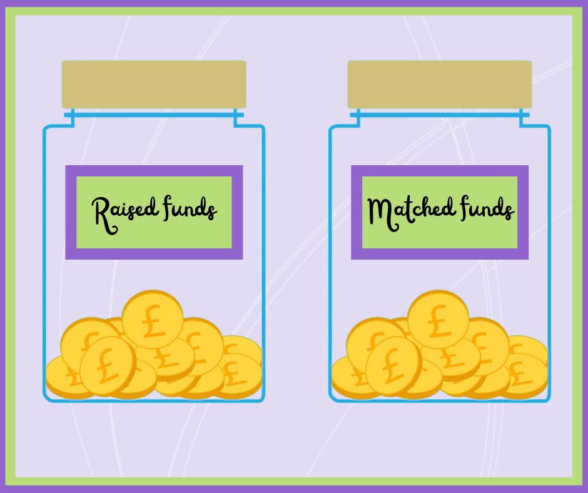

**Match funding is a simple way to maximise your fundraising efforts. Your employer could agree to match an amount for the funds you raise.** Some companies offer this on a pound-for-pound basis, while others specify the amount they are prepared to give.

If you work for one of the companies below, take a look at the information in the link.

If your company is not on the list, you can get in touch with your HR or CSR Department or management team to find out if they have a match funding scheme. If the answer is yes, please do let us know!

Please do contact your employer to ask about their match funding scheme. It is a really easy way of increasing your fundraising amount and such a boost for us as a charity.

|  |  |  |
| --- | --- | --- |
| **Company name** | **Does company provide match funding?** | **Link** |
| De La Rue | Offers a 'Give as You Earn' scheme for employees and will match their donations up to £500. | <https://www.delarue.com/about-us/corporate-responsibility/relationships/de-la-rue-in-the-community> |
| Deloitte Consulting | Every office has a champion who organises local events. Online fundraising calendar of national fundraising activities. Annual allocation of matched funded amount for staff fundraising events. | <https://www2.deloitte.com/uk/en/pages/charities-and-not-for-profit/articles/our-commitment-to-the-sector.html> |
| Deutsche Bank | Match funding and Give as You Earn match funding. | <https://www.db.com/what-we-do/responsibility/society/employee-engagement?language_id=1> |
| DHL | Application for employees to boost fundraising efforts with Match It! scheme. | <https://www.dhlukfoundation.org/apply-for-match-it/> |
| Experian | Match funding for employees up to £250. | <https://www.experian.co.uk/about-us/community-involvement/> |
| Fidelity Investments | Match funding for employees and provide two days volunteering a year. | <https://www.fidelity.co.uk/corporate-citizenship/> |
| First Bus | Match funding for up to £200. Application forms and instructions available via link. | <https://www.firstgroupplc.com/responsibility/foundations/community-engagement.aspx>) |
| Halifax | Part of Lloyds group. See Lloyds entry below. | See Lloyds entry below. |
| Lloyds | Match funding of £500 for fundraising events and can claim up to £500 a year for time spent outside working hours for voluntary time. | <https://www.lloydsbankfoundation.org.uk/about-us/matched-giving-faqs> |
| Legal and General | Sponsorship, time matching, and Give as You Earn. | <https://group.legalandgeneral.com/en/sustainability/supporting-communities> |
| Morrisons | Match-funding available. | <https://www.morrisonsfoundation.com/match-funding-request/> |
| Microsoft | Match-funding available. | <https://www.microsoft.com/en-us/corporate-responsibility/philanthropies/employee-engagement> |
| Royal and Sun Alliance | Match-funding available. | <https://www.neighbourly.com/MatchFundingRSA> |
| Thames Water | Pound-for-pound match funding scheme up to a maximum of £2,000 for registered charities. Option to support with Give as you Earn. | <https://www.thameswater.co.uk/about-us/responsibility/investing-in-our-communities> |
| Tideway | Put forward by fundraiser who was successful. | <https://www.tideway.london/> |
| UBS | Match funding available and Give as You Earn. | <https://www.ubs.com/global/en/ubs-society/philanthropy/donate.html#uk> |
| United Utilities | Match funding to any UK-registered charity up to £200 per person per year. | <https://www.unitedutilities.com/corporate/responsibility/communities/employee-involvement/> |